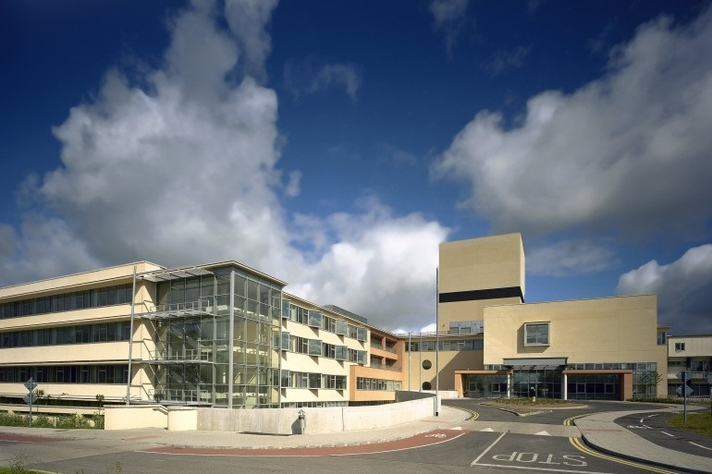

**Candidate Information Pack**

**Temporary Consultant in Palliative Care**

Connolly Hospital and St Francis Hospice (37 hours)

|  |  |
| --- | --- |
| **Job Title:** | Temporary Consultant in Palliative Care |
| **Closing date for applications:** |  |
| **Contract duration:** | Temporary Contract |
| **Contract Type:** | Public Only Consultant Contract 2023 |
| **Hours per week:** | 37 hours: 18.5 hours per week at Connolly Hospital, Blanchardstown. 18.5 hours per week at St Francis Hospice Blanchardstown |
| **Contact Details:** | For informal enquiries, contact Dr Faith Cranfield, Consultant in Palliative Care, [fcranfield@sfh.ie](mailto:fcranfield@sfh.ie) |

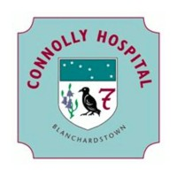

The HSE has created six new health regions. Each region is responsible for providing both hospital and community care for the people in that area. Bringing community health services and hospitals together means we can take a more patient-centred approach to healthcare.

HSE Dublin and North East provides health and social care to North Dublin, Louth, Meath, Monaghan and most areas of Cavan.

HSE Dublin and North East Region includes the following hospitals;

* Beaumont Hospital
* Cavan General Hospital
* Connolly Hospital
* Louth County Hospital
* Monaghan General Hospital
* Mater Misericordiae University Hospital
* National Orthopaedic Hospital Cappagh
* Our Lady’s Hospital Navan
* Our Lady of Lourdes Hospital
* Rotunda Hospital

**Connolly Hospital**

Connolly Hospital is located in the West Dublin Village of Blanchardstown. It services a catchment population of 331,000 in Dublin West (including Finglas West and Lucan), North Kildare and South County Meath, and is one of the fastest growing catchment population areas in the country. Connolly Hospital is a 400 bed Dublin Academic Teaching Hospital providing a range of acute medical and surgical clinical services, national Bowel Screen services, acute psychiatric services, psychiatry of old age residential and day services designated residential centres for older persons care, older person day care, outpatient services, diagnostic and support services. Emergency acute general clinical services are provided on a 365 day, 24 hour basis.

**Palliative Care Services**

St Francis Hospice, Dublin (SFHD) provides specialist palliative care services to North Dublin. SFHD provides inpatient unit care, outpatient services and a community based palliative care MDT service across two sites, at Raheny and Blanchardstown. Services are provided in line with Clinical Programme recommendations and patients with life-limiting conditions may be referred for symptom control, rehabilitative palliative care or end-of-life care. The successful candidate will be working as a member of a Consultant team supporting multidisciplinary palliative care across the inpatient unit and services for community based patients, in an evolving environment

**The following qualifications shall apply to this appointment:-**

**Professional Qualifications**

Registration as a specialist in the Specialist Division of the Register of Medical Practitioners maintained by the Medical Council in Ireland in the specialty of palliative care medicine .

**Entry to competition and subsequent appointment**

For the purposes of eligibility for entry to any competition or recruitment process associated with this post, a candidate must fulfil the eligibility requirements laid down in consultant appointment documents for the post.

The successful interviewee must be registered as a Specialist in the relevant specialty on the Specialist Division of the Register of Medical Practitioners maintained by the Medical Council of Ireland before taking up appointment. No candidate will be appointed as a Medical Consultant unless (s)he is registered as a Specialist in the Specialist Division of the Register of Medical Practitioners maintained by the Medical Council of Ireland.

Age restriction shall only apply to a candidate where he/she is not classified as a new entrant (within the meaning of the Public Service Superannuation (Miscellaneous Provisions) Act, 2004). A candidate who is not classified as a new entrant must be under 65 years of age on the first day of the month in which the latest date for receiving completed application forms for the office occurs.

**Section 62 post (This section only applies to Section 62 posts)**

It is noted that this post of Consultant in Palliative Care is considered to carry with it duties involving the teaching of clinical medicine and/or the conduct of medical research under the direction of the Royal College of Surgeons in Ireland. Therefore this post is considered a Section 62 post under the Health Act 1953 as amended by the Health Act 2004.