-

**Candidate Information Pack**

**Consultant in Emergency Medicine**

Cavan General Hospital (37 hours)

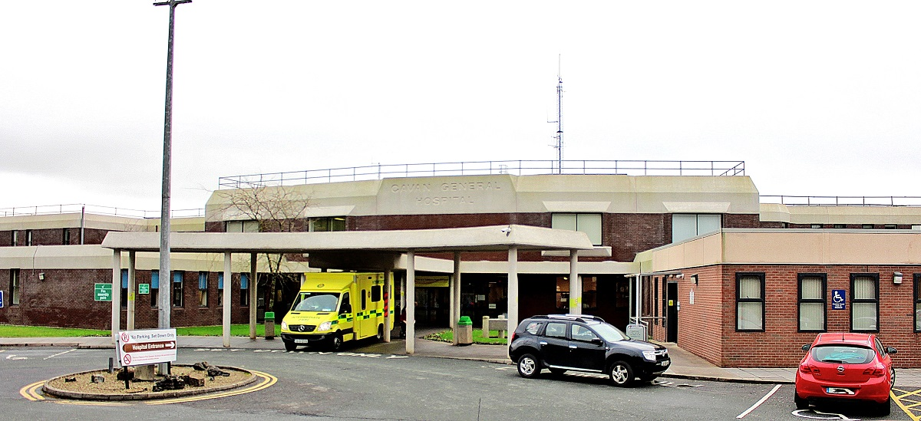

|  |  |
| --- | --- |
| **Job Title:** | Consultant in Emergency Medicine |
| **Closing date for applications:** | Friday, 11th July @ 12 noon |
| **Contract duration:** | Permanent |
| **Contract Type:** | Public Only Consultant Contract 2023 |
| **Hours per week:** | 37 hours Cavan General Hospital |
| **Contact Details:** | [ConsultantHR@beaumont.ie](mailto:ConsultantHR@beaumont.ie) – for application queries.  Enquiries relating specifically to this post or informal visits should be directed to:  Dr Val Gough, Clinical Director at Cavan General Hospital – Tel: 049 4376000. |





The HSE has created six new health regions. Each region is responsible for providing both hospital and community care for the people in that area. Bringing community health services and hospitals together means we can take a more patient-centred approach to healthcare.

HSE Dublin and North East provides health and social care to North Dublin, Louth, Meath, Monaghan and most areas of Cavan.

HSE Dublin and North East Region includes the following hospitals;

* Beaumont Hospital
* Cavan General Hospital
* Connolly Hospital
* Louth County Hospital
* Monaghan General Hospital
* Mater Misericordiae University Hospital
* National Orthopaedic Hospital Cappagh
* Our Lady’s Hospital Navan
* Our Lady of Lourdes Hospital
* Rotunda Hospital

**CAVAN MONAGHAN HOSPITAL**

Cavan & Monaghan Hospital currently provides services to the population of both counties and its catchment area extends to counties Meath, Longford and Leitrim. All acute inpatient services are based in Cavan Monaghan Hospital. Cavan Monaghan Hospital provides extensive outpatient, theatre and day services. Cavan Monaghan Hospital also provides a wide range of support services, including: pathology, radiology, pharmacy, physiotherapy, speech therapy and occupational therapy.

Cavan & Monaghan Hospital is a bi-located site providing services to the population of both counties and its catchment area extends to counties Meath, Longford and Leitrim. It has a total of 421 beds with 286 of these representing acute in-patient beds. All acute inpatient services are based in Cavan Monaghan Hospital; there were approximately 17,000 acute admissions in 2018. Monaghan Hospital's primary role includes the continuing care for medically discharged patients requiring inpatient step-down and rehabilitation care.

Cavan & Monaghan Hospital is a teaching hospital with links to the Royal College of Surgeons, Royal College of Physicians and the Dundalk Institute of Technology. Both sites are actively engaged with HIQA (Health Information & Quality Authority) in meeting their standards to ensure they continually strive to provide a high quality service.

Cavan & Monaghan Hospital has an Emergency Department, an Acute Medical Admissions Unit, 5 General Medical wards, 1 General Surgery ward, an acute surgical assessment unit (ASAU) a maternity ward, a paediatric ward, a Paediatric assessment unit (PAU) an ICU, a SCBU, and a CCU. It also has 4 operating theatres, a renal dialysis unit, a surgical day ward, an endoscopy / bronchoscopy unit, a haematology / oncology day ward, and an interventional radiology unit. Orthopaedic, vascular, urological and neurological services are provided by visiting consultants with sessional commitments. The hospital provides services for the care of paediatric and adult patients with cystic fibrosis; the paediatric ward has recently been extended and refurbished to include the provision of 2 high specifications, neutral pressure isolation rooms.

**EMERGENCY MEDICINE SERVICES**

Our Emergency Department has on average 110 presentations per day. We have an Acute Medical Assessment Unit, a Minor Injuries Unit (Monaghan), a Surgical Assessment Unit, a Paediatric Assessment Unit in operation in Cavan & Monaghan Hospital.

**Useful Links**

|  |  |
| --- | --- |
| **Our website:** | <https://www.hse.ie/eng/services/list/3/acutehospitals/hospitals/cavanmonaghan/cavan-monaghan-hospital.html> |

**Duties and Responsibilities:**

As outlined in the consultants’ contract but not limited to:

1. To participate in development of and undertake all duties and functions pertinent to the Consultant’s area of competence, as set out within the Clinical Directorate Service Plan[1] and in line with policies as specified by the Employer.
2. To ensure that duties and functions are undertaken in a manner that minimises delays for patients and possible disruption of services.
3. To work within the framework of the hospital / agency’s service plan and/or levels of service (volume, types etc.) as determined by the Employer. Service planning for individual clinical services will be progressed through the Clinical Directorate structure or other arrangements as apply.
4. To co-operate with the expeditious implementation of the Disciplinary Procedure (attached at Appendix II).
5. To formally review the execution of the Clinical Directorate Service Plan with the Clinical Director / Employer periodically. The Clinical Directorate Service Plan shall be reviewed periodically at the request of the Consultant or Clinical Director / Employer. The Consultant may initially seek internal review of the determinations of the Clinical Director regarding the Service Plan.
6. To participate in the development and operation of the Clinical Directorate structure and in such management or representative structures as are in place or being developed. The Consultant shall receive training and support to enable him/her to participate fully in such structures.
7. To provide, as appropriate, consultation in the Consultant’s area of designated expertise in respect of patients of other Consultants at their request.
8. To ensure in consultation with the Clinical Director that appropriate medical cover is available at all times having due regard to the implementation of the European Working Time Directive as it relates to doctors in training.
9. To supervise and be responsible for diagnosis, treatment and care provided by non-Consultant Hospital Doctors (NCHDs) treating patients under the Consultant’s care.
10. To participate as a right and obligation in selection processes for non-Consultant Hospital Doctors and other staff as appropriate. The Employer will provide training as required. The Employer shall ensure that a Consultant representative of the relevant specialty / sub-specialty is involved in the selection process.
11. To participate in clinical audit and proactive risk management and facilitate production of all data/information required for same in accordance with regulatory, statutory and corporate policies and procedures.
12. To participate in and facilitate production of all data/information required to validate delivery of duties and functions and inform planning and management of service delivery.

**Skills/competencies and/or knowledge**

* Demonstrate evidence of effective planning and organising skills including awareness of resource management and importance of value for money.
* Demonstrate evidence of ability to empathize with and treat patients, relatives and colleagues with dignity and respect.
* Demonstrate evidence of ability to manage a busy Clinical area effectively.
* Demonstrate an ability to participate fully in audit and clinical governance programmes.

**The above Job Description is not intended to be a comprehensive list of all duties involved and consequently, the post holder may be required to perform other duties as appropriate to the post which may be assigned to him/her from time to time and to contribute to the development of the post while in office.**

A panel may be formed from which other permanent vacancies for Consultants in Emergency Medicine at Cavan General Hospital may be filled.

1.