Candidate Information Pack

**Consultant Cardiologist**

Cavan Hospital (18.5 hours pw) & Primary Care, Cavan Monaghan (18.5 hours pw)

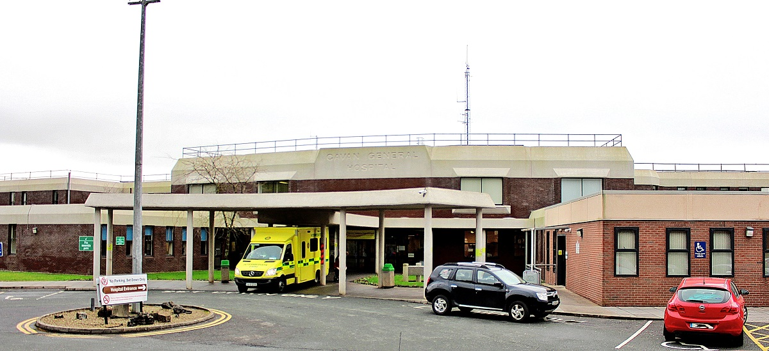

|  |  |
| --- | --- |
| **Job Title:** | Consultant General Surgeon |
| **Closing date for applications:** | **DDMMYY** |
| **Contract duration:** | Permanent |
| **Contract Type:** | Public Only Consultant Contract 2023 |
| **Hours per week:** | 37 hours Cavan General Hospital |
| **Contact Details:** | [ConsultantHR@beaumont.ie](mailto:ConsultantHR@beaumont.ie) – for application queries.  Enquiries relating specifically to this post or informal visits should be directed to: Dr Val Gough, Clinical Director at Cavan General Hospital – email: [val.gough@hse.ie](mailto:val.gough@hse.ie) |

|  |  |
| --- | --- |
| **Job Title:** | Consultant Cardiologist |
| **Closing date for applications:** | 20/05/2025 @ 12 noon |
| **Contract duration:** | Permanent |
| **Contract Type:** | Public Only Consultant Contract 2023 |
| **Hours per week:** | 18.5 hours per week, Cavan Hospital & 18.5 hours per week Primary Care, Cavan/Monaghan |
| **Contact Details:** | [ConsultantHR@beaumont.ie](mailto:ConsultantHR@beaumont.ie) – for application queries, enquiries relating specifically to this post or informal visits should be directed to: Dr Val Gough, Clinical Director,  Phone Number: 049-4376000 or email: [Val.Gough@hse.ie](mailto:Val.Gough@hse.ie) |





The HSE has created six new health regions. Each region is responsible for providing both hospital and community care for the people in that area. Bringing community health services and hospitals together means we can take a more patient-centred approach to healthcare.

HSE Dublin and North East provides health and social care to North Dublin, Louth, Meath, Monaghan and most areas of Cavan.

HSE Dublin and North East Region includes the following hospitals;

* Beaumont Hospital
* Cavan General Hospital
* Connolly Hospital
* Louth County Hospital
* Monaghan General Hospital
* Mater Misericordiae University Hospital
* National Orthopaedic Hospital Cappagh
* Our Lady’s Hospital Navan
* Our Lady of Lourdes Hospital
* Rotunda Hospital

**Cavan Monaghan Hospital**

Cavan Monaghan Hospital is a bi-located site providing services to the population of both counties and its catchment area extends to counties Meath, Longford and Leitrim. It has a total of 421 beds with 286 of these representing acute in-patient beds. All acute inpatient services are based in Cavan Monaghan Hospital; there were approximately 17,000 acute admissions in 2018. Monaghan Hospital's primary role includes the continuing care for medically discharged patients requiring inpatient step-down and rehabilitation care.

Cavan & Monaghan Hospital is a teaching hospital with links to the Royal College of Surgeons, Royal College of Physicians and the Dundalk Institute of Technology. Both sites are actively engaged with HIQA (Health Information & Quality Authority) in meeting their standards to ensure they continually strive to provide a high quality service.

Cavan Monaghan Hospital has an Emergency Department, an Acute Medical Admissions Unit, 5 General Medical wards, 1 General Surgery ward, an acute surgery assessment unit (ASAU) a maternity ward, a paediatric ward, a paediatric assessment unit (PAU) an ICU, a SCBU, and a CCU. It also has 4 operating theatres, a renal dialysis unit, a surgical day ward, an endoscopy / bronchoscopy unit, a haematology / oncology day ward, and an interventional radiology unit. Orthopaedic, vascular, urological and neurological services are provided by visiting consultants with sessional commitments. The hospital provides services for the care of paediatric and adult patients with cystic fibrosis; the paediatric ward has recently been extended and refurbished to include the provision of 2 high specifications, neutral pressure isolation rooms.

**CARDIOLOGY SERVICES**

**Current Cardiac Services in Cavan General Hospital;**

**The Multi-Disciplinary Team in Cavan and Monaghan Hospitals are:**

* 1 visiting Consultant- 0.4 WTE
* Shared Registrar and SHO - 2 WTE
* Cardiac Physiologists- 3 WTE
* Nurse Specialists in heart failure - 3 WTE
* Nurse Specialists in cardiac rehabilitation- 2 WTE

Multi task attendants 3 WTE

This visiting Cardiologist links with the Medical Consultants in relation to complex cases on the wards and manages OPD clinics for complex cardiac patients

* ECHO/Stress Tests and Holter Monitors are conducted in both Cavan and Monaghan Hospitals
* Transesophageal Echocardiogram(TOES) are available in both hospitals .
* A cardioversion pathway can be facilitated via Coronary Care or theatre

The post holder will work 50:50 between the Ambulatory Care Hub for Chronic Disease Management Cavan Monaghan and Cavan General Hospital/Monaghan Hospital.

The post holder will attend meetings in the following specialties

* Multidisciplinary Complex cases meetings
* Grand Rounds
* Integrated Discharge Planning

This will allow the Consultant to access Continuing Medical Education and maintain competencies as well as develop links with existing teams, a cross-interface with patients and allied staff who are delivering services across both a community and acute healthcare setting.

This new post will drive integration in ambulatory care between the hospital and community services and the post holder will work with colleagues across these services to develop and implement ambulatory care pathways and to manage cardiovascular disease and associated

co-morbidities, within the community setting, where appropriate.

The Integrated Care Consultant will work across the Hospital, Specialist, and ambulatory care hub settings (50:50 split) and will work to develop the alternative out patient pathways in their specialty in the Cardiology hub.

The Integrated Cardiology Multidisciplinary Team will have a base in the Cavan Monaghan Chronic Disease Management Hub in a new purpose built building, adjacent to Cavan General Hospital with a spoke operation located in the grounds of St Davnet’s Campus, Monaghan Town.

The post holder will sit on the Cavan Monaghan Cardiology Integrated Care Implementation Group, to ensure collaboration and integration between hospital and community services. Additional Integrated Care Consultants for each chronic disease specialty in Respiratory and Endocrinology are in position in Cavan Monaghan.

**The principal Multi-disciplinary Cardiology Team in the Cavan Monaghan Chronic Disease Hub are:**

* Integrated Consultant Cardiologist ( 50:50 Community, Cavan Monaghan Hospitals) 1 WTE
* CNS Cardiovascular Disease 3 WTE
* Senior Physiotherapist (Cardiology) 1.0 WTE
* Cardiac Rehabilitation Coordinator 1.0 WTE
* Staff Nurse Cardiac Rehabilitation 1.0 WTE
* Admin Assistant (IV) Cardiac Rehabilitation team 0.5 WTE
* Clinical Psychologist 0.2 WTE
* 1 WTE Operational Lead Manager
* 1 Senior Cardiac Physiologist
* 1 CNS Acute /Hub to support Consultant Clinics

**Useful Links**

|  |  |
| --- | --- |
| **Our website:** | <https://www.hse.ie/eng/services/list/3/acutehospitals/hospitals/cavanmonaghan/cavan-monaghan-hospital.html> |

**Job Description and Responsibilities**

**STANDARD DUTIES**:

* To provide, as appropriate, consultation in the Consultant’s area of designated expertise in respect of patients of other Consultants at their request.
* To participate in clinical audit and proactive risk management and facilitate production of all data/information required for same in accordance with regulatory, statutory and corporate policies and procedures.
* To participate in and facilitate production of all data/information required to validate delivery of duties and functions and inform planning and management of service delivery.
* Participate in teaching, including undergraduate and postgraduate teaching and conference commitments of the department and of the hospital for medical, nursing and other staff.
* To ensure that duties and functions are undertaken in a manner that minimizes delays for patients and possible disruption of service.
* To work within the framework of the hospitals’ service plans and levels of service (volume, types etc) as determined by Cavan & Monaghan Hospital. Service planning for individual clinical services will be progressed through the Clinical Directorate structure or other arrangements as apply.
* Participate in the development of agreed care protocols.

Standard Duties and Responsibilities for all Consultant posts are as per Section 4 and Section 10 of the POCC23:

The Employee is hereby employed as a consultant. The Employee will be clinically independent in relation to decisions on the diagnosis, treatment and care of individual patients. This clinical independence derives from the specific relationship between the patient and the Employee. In that relationship, the patient places trust in the consultant who is personally involved in the patient’s care to make clinical decisions in the patient’s best interests and to take continuing responsibility for the consequences of that consultant’s decisions.

The Employee acknowledges that they are subject to statutory and regulatory requirements and corporate policies and procedures including those adopted for implementation by the national clinical programmes.

The Employee has a substantial and direct involvement in the medical diagnosis, treatment and delivery of care to patients.

The Employee may discharge their responsibilities through:

1. a direct professional relationship with the patient;
2. shared responsibility with other consultants who contribute significantly to patient management; and
3. (Subject to the following paragraph of this clause) delegation of aspects of the patient’s care to other appropriate members of staff.

The Employee will only delegate responsibility to other doctors or staff members where the delegation is consistent with the continued provision of an appropriate level of diagnosis, treatment and care to the patient in respect of the relevant episode of care. Notwithstanding any such delegation, the Employee will retain a continuing overall responsibility for the care of the patient.

The determination of the range, volume and type of services to be provided and responsibility for the provision of same within available resources rests with the Employer. Services not provided because of a resource limit are the responsibility of the Employer and not the Employee.

The Employee will generally work as part of a consultant team. The primary purpose of consultant teams is to ensure consultant-provided services to patients on a continuing basis. In effect this requires that the Employee will provide diagnosis, treatment and care to patients who are under the care of other consultants on their consultant team and vice versa. This may include discharge and further treatment arrangements, as appropriate.

The membership of the Employee’s consultant team will be determined by the Employer in the context of the local working environment. The team may be defined at specialty/sub-speciality level or under a more broadly based categorisation, such as “general medicine” or “general surgery”.

The work of the Employee will be determined by reference to the Clinical Directorate Service Plan that applies from time to time. The principles underpinning the preparation of the Clinical Directorate Service Plan are set out in Appendix 3 of the POCC23.

The initial scope of this post is as set out in the letter of approval. The main duties of the Employee’s position (as of the Commencement Date) are set out in the job description attached at Appendix 2 of the POCC23. The scope and duties of the post may be changed by the Clinical Director from time to time provided the Clinical Director consults the Employee before making any such change.

In addition to or instead of their normal duties, the Employee may be required to undertake other duties as may be assigned to them provided such other duties are consistent with

* + - 1. The role of a consultant having regard to the letter of approval and the duties set out at Appendix 1 and Appendix 2 of the POCC23 respectively and
      2. The Employee’s clinical speciality (as recognised in their registration on the Specialist Division or the Register of Dental Specialist).

Any other duties that are assigned further to the preceding paragraph will be discussed between the Employee and their Clinical Director/Executive Clinical Director/line manager and will be incorporated into the Employee’s work plan.

The Employee is required to cooperate with the delivery of national clinical programmes, national health strategies and nationally agreed models of care. If any of these materially change the terms and conditions of this contract, the same will be subject to negotiation. Such cooperation will not impinge on the clinical independence set out in clause 4 of the POCC23.

In Addition:

* Demonstrate evidence of effective planning and organising skills including awareness of resource management and importance of value for money Demonstrate evidence of ability to empathise with and treat patients, relatives and colleagues with dignity and respect.
* Demonstrate evidence of ability to manage a busy labour ward effectively. Demonstrate an ability to engage in clinical trials.
* Demonstrate an ability to participate fully in audit and clinical governance programmes
* The post holder will take part in Clinical Audit and other Health Care Initiatives.
* To ensure that duties and functions are undertaken in a manner that minimises delays for patients and possible disruption of services.
* To provide, as appropriate consultation in the Consultants area of designated expertise in respect of patient of other Consultants at their request.
* To supervise and be responsible for diagnosis, treatment and care provided by NCHDs treating patients under the Consultants care.

**Skills/competencies and/or knowledge**

* Leadership and management skills
* Communication skills, compassion and a good bedside manner. Effective decision making.
* Ability to solve problems, good practical skills
* Demonstrate evidence of effective planning and organising skills including awareness of resource management and importance of value for money.
* Demonstrate evidence of ability to empathize with and treat patients, relatives and colleagues with dignity and respect.
* Demonstrate evidence of ability to manage a busy Clinical area effectively.
* Demonstrate an ability to participate fully in audit and clinical governance programmes.

**The above Job Description is not intended to be a comprehensive list of all duties involved and consequently, the post holder may be required to perform other duties as appropriate to the post which may be assigned to him/her from time to time and to contribute to the development of the post while in office.**