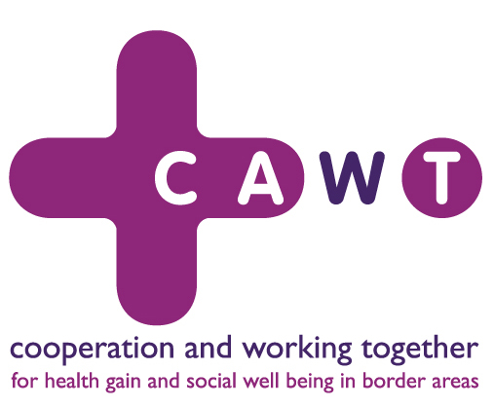

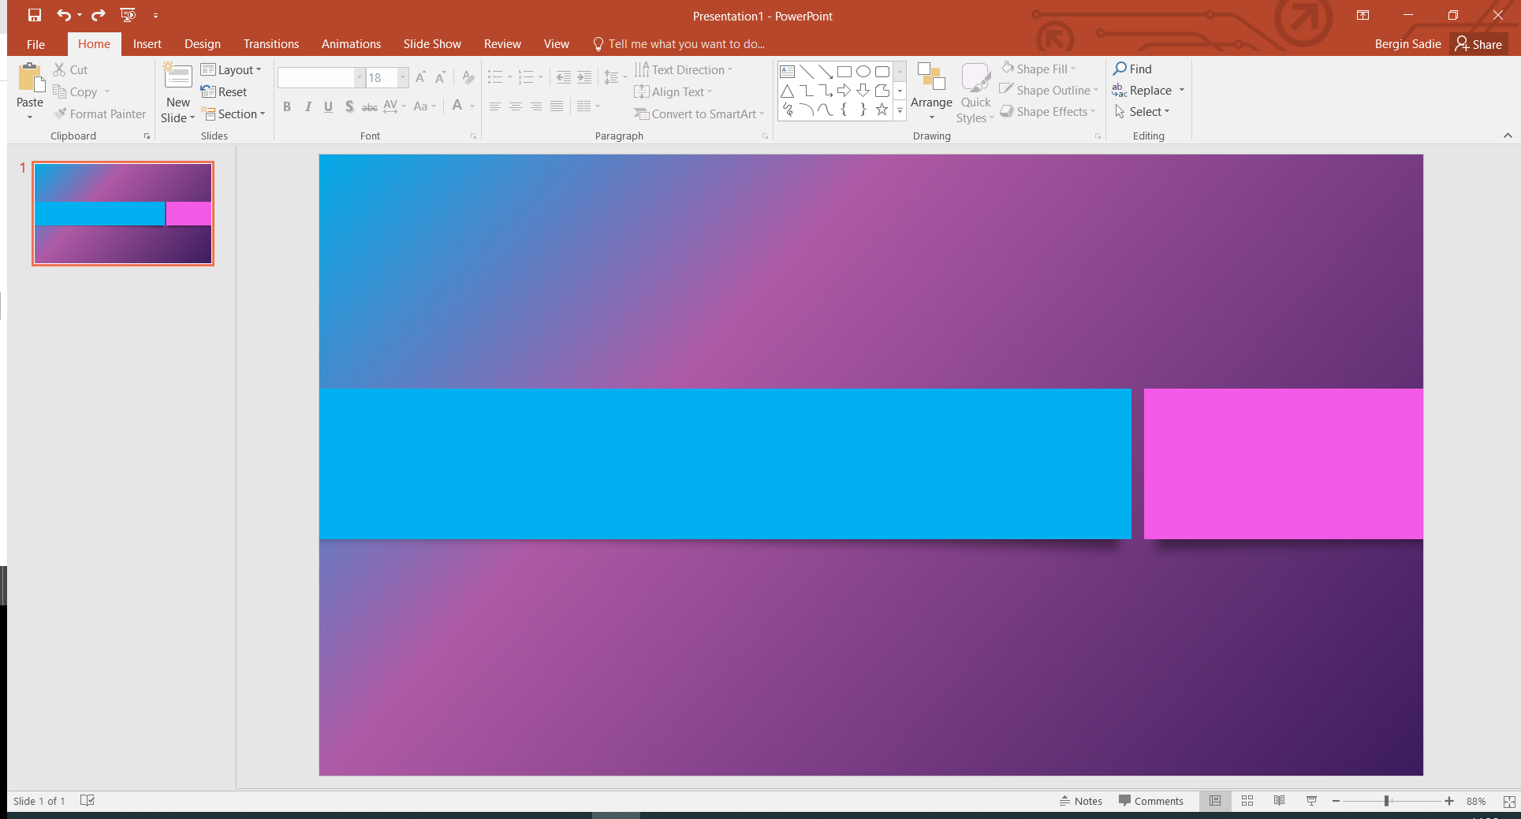
CAWT PEACEPLUS PROJECTS
PROJECT MANAGER APPLICANT INFORMATION

HSE
December 2024
PEACEPLUS THEME 4.1 CAWT PROJECTS SUMMARY

CAWT Community Connection & Wellbeing Project (CCWP)

The project’s overall objective is to address the long-standing social & economic challenges that continue to impact negatively on the mental health and wellbeing of Ireland/Northern Ireland border communities and to promote peace & prosperity within the border region.

The new Cross Border, community-based CAWT Community Connections and Wellbeing project (CCWP) aims to implement a psychosocial model, focusing on addressing societal influences such as social, economic, cultural and environmental issues. Statutory/Voluntary/Community sectors, working collaboratively, will develop and deliver interventions for people with mild and/or emerging mental health difficulties by enabling access to early intervention programmes and support through psychosocial mental health & wellbeing programmes.

The Project will cover four cross border locations:
- WHSCT/HSE (Limavady, Derry/Londonderry, Strabane, Central & Northern Donegal)
- HSE/WHSCT(South Donegal, Sligo, Leitrim, West Cavan, Fermanagh, Omagh)
- SHSCT/HSE (Newry, Mourne and Down areas of SHSCT, Louth)
- HSE/SHSCT (East Cavan, Monaghan, Armagh, Dungannon)
The Project Manager for CCWP will be responsible for project activity and delivery across the entire project area and will be expected to travel to cover the entire region as required.

The CCWP Project Manager base* will be agreed by the Project Board and the successful candidate upon appointment. The available base locations are:
Contracting Organisation | Base location
HSE | Monaghan
WHSCT | Derry/Londonderry
SHSCT | Newry

* Successful candidates will be required to take up duty at a base in one of the designated locations above. The locations outlined will be the sole determinant as to where candidates will be based.

CAWT Early Frailty Intervention Project (EFIP)

The overall objective of the CAWT Early Frailty Intervention Project (EFIP) is to intervene earlier in order to help lessen the projected increase in pressures on our HSC services.

The project will establish a new jointly developed Cross Border community-based Early Intervention Frailty infrastructure, to identify people living with/at risk of developing frailty earlier and jointly deliver early/preventative interventions within their local community to help slow down or reverse the process. Statutory partners, working collaboratively, will provide clinical support and episodes of health and social care to older people living with/at risk of developing frailty and provide a programme of care which could include early frailty assessment, screening, education and participation in community based activities.

The Project will cover four cross border locations:
- WHSCT/HSE (Limavady, Derry/Londonderry, Donegal)
- HSE/WHSCT(Sligo, Leitrim, Fermanagh, Omagh)
- SHSCT/HSE (Cavan, Monaghan, Craigavon, Banbridge, Dungannon)
- HSE/SHSCT (Newry, Mourne, Armagh, Louth)
The Project Manager for EFIP will be responsible for project activity and delivery across the entire project area and will be expected to travel to cover the entire region as required.
The EFIP Project Manager base* will be agreed by the Project Board and the successful candidate upon appointment. The available base locations are:
Contracting Organisation | Base location
HSE | Donegal or Sligo or Cavan or Louth
WHSCT | Derry/Londonderry or Omagh
SHSCT | Armagh or Lurgan

*Successful candidates will be required to take up duty at a base in one of the designated locations above. The locations outlined will be the sole determinant as to where candidates will be based.

CAWT Healthier Futures Project (HFP)

The overall objective of the project is to develop and implement a more synergised Cross Border and Cross Community model of support for all age ranges, which is a jointly developed solution to tackle overweight/obesity, comprised of both:
- Community-based early intervention support programmes, including a range of physical activity, healthy eating and behavioural management programmes to help prevent obesity.
- The project will develop new adult weight management programmes in NI
The Healthier Futures project will focus on developing, enhancing and complementing existing models of care. This will involve working in partnership with statutory and Voluntary Community stakeholders to provide targeted episodes of care for adults (NI), children (Ireland) and their families to improve their diet and participate in more physical activity and reduce the risk of related harm for those living with overweight/obesity.

The Project will have two models covering the following locations:
- HSE - Donegal, Sligo, Leitrim, Cavan, Monaghan and Louth
Contracting Organisation | Base location
HSE | South Donegal or Cavan or Monaghan or Louth
WHSCT | Derry/Londonderry or Omagh or Enniskillen
SHSCT | Armagh or Dungannon or Newry
- HSCNI – Southern Health and Social Care Trust and Western Health & Social Care Trust areas
The Project Manager for HFP will be responsible for project activity and delivery across the entire project area and will be expected to travel to cover the entire region as required.
The HFP Project Manager base* will be agreed by the Project Board and the successful candidate upon appointment. The available base locations are:
*Successful candidates will be required to take up duty at a base in one of the designated locations above. The locations outlined will be the sole determinant as to where candidates will be based.

CAWT Early Intervention Support Youth Hubs (EASY)

The EASY Project aims to establish a new early intervention support service for children, young people and families living in the border area with social, emotional or behavioural issues consistent with neurodevelopmental type conditions or who have been recently diagnosed.

The project will lead to improved health and wellbeing through the provision of high quality and targeted early intervention supports that best meet the needs of families within their local communities and in partnership with voluntary/community providers. The project aims to ensure equal access by applying an integrated approach, helping to reduce health inequalities within the Programme area and help to foster resilience within the family, community and wider health systems by diverting pressures from health and care services through earlier intervention.

The Project will cover four cross border locations:
- WHSCT (Limavady, Derry/Londonderry, Strabane, Fermanagh, Omagh)
- HSE West and North West (Donegal, Sligo, Leitrim, West Cavan)
- SHSCT(Armagh, Dungannon, Newry, Mourne)
- HSE Dublin and North East (East Cavan, Monaghan, Louth)
The Project Manager for EASY will be responsible for project activity and delivery across the entire project area and will be expected to travel to cover the entire region as required.
The EASY Project Manager base* will be agreed by the Project Board and the successful candidate upon appointment. The available base locations are:
Contracting Organisation | Base location
HSE | Donegal or Sligo or Cavan or Monaghan or Louth
WHSCT | Derry/Londonderry or Omagh or Enniskillen
SHSCT | Armagh or Dungannon or Newry
*Successful candidates will be required to take up duty at a base in one of the designated locations above. The locations outlined will be the sole determinant as to where candidates will be based.
CAWT Community Alcohol Detox+ Project (CAD+)
The project’s overall objective is to help reduce the harms to individuals, families and communities caused by substance use, specifically alcohol, and support clients to address the associated socio-economic issues (e.g. poverty, homelessness, employment, mental health, loneliness etc.) that continue to impact negatively on their health and wellbeing.

The CAD+ project will support people with Alcohol Related Harm/Dual Diagnosis to prepare for and complete alcohol detox/alcohol harm reduction programmes safely at home/in the community followed by providing wraparound services to support them and their families/carers in recovery.

The Project will cover the following areas:
- HSE West and North West (Donegal, Sligo, Leitrim, West Cavan)
- HSE Dublin and North East (East Cavan, Monaghan, Louth)
- Southern Health and Social Care Trust and Western Health & Social Care Trust areas
The Project Manager for CAD+ will be responsible for project activity and delivery across the entire project area and will be expected to travel to cover the entire region as required.

The CAD+ Project Manager base* will be agreed by the Project Board and the successful candidate upon appointment. The available base locations are:
Contracting Organisation | Base location
HSE | Letterkenny or Sligo or Cavan or Louth
WHSCT | Omagh
SHSCT | Armagh

* Successful candidates will be required to take up duty at a base in one of the designated locations above. The locations outlined will be the sole determinant as to where candidates will be based.

Frequently asked questions

How will my base location/employing organisation be determined?
Following the interview process the successful candidate will be advised of the interview outcome. The CAWT HR Manager will then engage in discussions with the successful candidate and the Project Board to discuss available base locations. Candidate should be aware that the base location must be within the area of the employing organisation i.e. if a HSE contract then the base location must be within a HSE area and likewise for Western Health and Social Care Trust and Southern Health and Social Care Trust.
Project Managers will be based with one of the project delivery teams agreed by the Project Board and locations listed above will be subject to change depending on service demands.

What will my Terms and Conditions be?
The Terms and Conditions will be determined by your employing organisation. Following agreement of your employing organisation and base location you will be contracted following standard processes of the employing organisation, this will include all relevant pre-employment checks for that organisation and you will be placed on the Terms and Conditions of the organisation i.e. HSE/WHSCT/SHSCT.

Can I work remotely/work from home?
The Project Manager will be expected to have a visible presence across the project delivery region and will be required to work remotely when away from their base on project business. Requests to work from home will be subject to Project Board approval and will be take into consideration business needs and the relevant employing organisations policy.

Will I have to travel?
This role will require travel of the Project Manager to ensure the project is fully implemented and successfully delivered. The Project Manager will be responsible for management of the project and associated staff across the border region.
The Project Manager may be asked to travel beyond the project deliver region if required.

Can I apply for Secondment?
The Project Manager posts are 3 year fixed term/specified purpose contracts, should you wish to seek a secondment you should seek advice from your current employing organisation.

How do I apply for this campaign?
Complete all areas of the application form ensuring to clearly demonstrate your experience under each question on how you meet the required criteria. Failure to do so may result in you not being shortlisted and called forward to Interview. Ensure to return your completed application form by the closing time and date of the campaign.

Can I apply for this campaign if I am not currently employed by the HSE or HSC?
Yes, we welcome applications from all suitably qualified individuals who meet the eligibility criteria for this role.

I am not familiar with the HSE Recruitment Process, is there any support available?
Three support modules, for candidates engaging in the HSE recruitment process, are now available on the HSE Website. You can access the modules by using the following link https://www.hse.ie/eng/staff/jobs/recruitment-process/
The elearning modules are also available on HSeLand. They can be accessed by entering ‘Getting a Job in the HSE’ in the search function.
Any further information on applying for this post?
- You must submit a fully completed Application Form particular to this post by email only.
- Proposed interview dates will be indicated at a later stage. Please note you may be called forward for interview at short notice.
- There is no need to sign emailed applications; we will request candidates to sign their application form at a later stage.
- As we require the same information from all candidates in order to make fair decisions on their applications we will not be able to process applications by CV or any other method.
- Email applications will receive a response within 2 working days, which will let you know that we received your email. Please note a delivery receipt from your email provider should not be accepted as validation that the NRS has received your email. Only a response from the email address to which you sent your email is confirmation that the NRS has received your email. Therefore, if you have not received an email response from the NRS within 5 working days, we highly recommend that you contact us by emailing recruitmanagement@hse.ie to verify that your email has been received.
- To ensure that the NRS has no issue in viewing your email, please ensure that you do not mark your email private before submitting it. For example if you are using Microsoft Outlook you can check the setting by clicking File, then Properties and ensuring the Sensitivity setting is Normal and not Private.
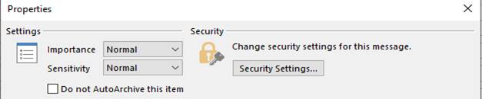

- We check eligibility of the applicants after the closing date and time therefore it is important that you ensure you have fully demonstrated your eligibility for the role in your application form. If you omit information in this section pertinent to the eligibility criteria you will be deemed ineligible and subsequently not called forward to interview. This means that if your application is blank, you have sent the wrong version of your application form, have no internet access etc or that you have not attached requested relevant supporting documentation, etc you will not be processed further.
- As we are only accepting applications by email applications must be submitted as a Microsoft Word format only. Applications stored on personal online storage sites, e.g. Onedrive, Cloud, Dropbox, Google Drive etc will not be accepted, applications submitted in other file formats e.g. Google Docs will not be accepted. Please pay particular attention to ensure that your application is attached as an attachment (not a link to an on line storage site e.g. Google Drive) when emailing your application. In order to ensure that your email is not quarantined your email attachments should not exceed a 3mb limit. If you are required to submit supporting documentation with your application form which exceeds 3mb you must reduce the size of the documentation by compressing (zip) the documents otherwise your email may not be received by the closing date of the campaign.
- To ensure that you do not miss out on any email communication it is highly recommended that you check your spam and junk folder on a regular basis
- The National Recruitment Service can only accept complete applications received by the closing date and time of Wednesday 10th December 2025 at 3:00PM. If you submit more than one application the last one received prior to the closing date and time is the version that will be considered.

Please note that the National Recruitment Service will mainly contact you by email therefore it is most important that your email address is included on your application form. It is your responsibility to ensure you have access to your emails. If you choose to use your work email addresses you may receive communications that have a time deadline requirement while you may be working away or on leave. We recommend you use a personal email address to which you have regular access.

