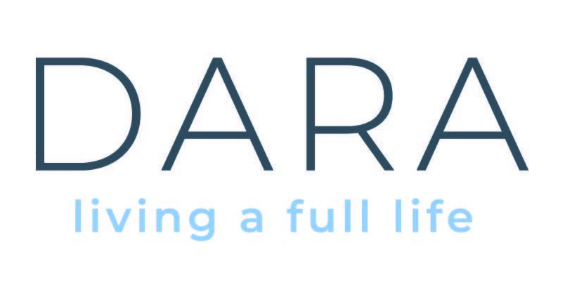

Person In Charge
Social Care Leader or Registered Nurse

The role of Person In Charge is to work alongside and lead a staff team on all aspects of the management of a Designated Centre including meeting Care and Support regulations and HIQA standards. The Person in Charge will have experience in the area delivering high quality supports to people with intellectual disabilities. You will be a person centred professional, a capacity builder and community connector with a strong commitment towards human rights and inclusion. The Person In Charge will be a highly organised and responsive leader with excellent verbal and written communication skills.

Terms:
This is a Permanent, Full-Time position based in Celbridge.
39 hours per week Monday-Saturday (Rostered hours will be decided based on the needs of the Designated Centre).
Sleepovers if required in an emergency.
HSE PayScale’s August 2025.

Essential Criteria:
- A recognized professional qualification minimum level 7 in Social Care, Nursing or equivalent.
- On CORU register for Social Care or Nursing Board of Ireland register
- A Management/Supervisor qualification relevant to the role.
- Proven track record of performance within current role.
- Strong natural leadership, interpersonal and communication skills.
- Experience of managing/supervising a team - supporting people with intellectual disabilities in a community setting to live self-directed lives.
- An ability to inspire, lead and manage a team of support workers, be solution focused and highly motivated.
- Proven track record of promoting and driving and achieving outcomes with people to develop and maintain Socially Valued Roles
- In-depth knowledge of Care and Support Regulations 2013, the HIQA inspection processes.
- Full, Clean Drivers licence.

HOW TO APPLY:
Applications via cover letter and up to date CV to be forwarded to sarah@daracommunityliving.ie
Closing date for receipt of CV is no later than 5pm on 24th July 2026

Shortlisting will apply, only candidates shortlisted for interview will be contacted.
Dara is an equal opportunities employer

