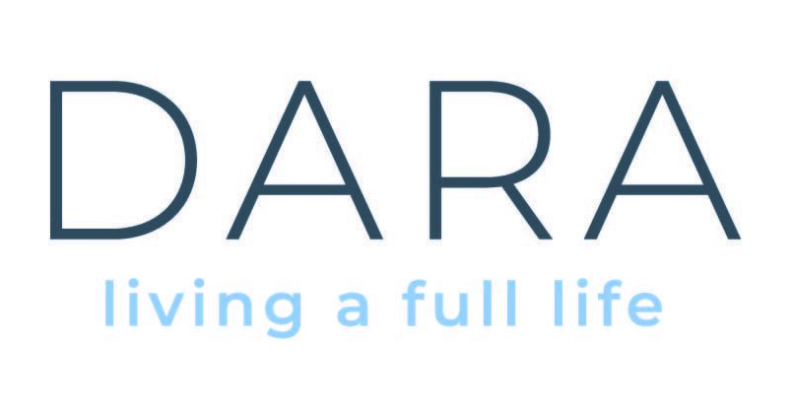

Job Specification - Team Leader – Celbridge Co Kildare
Full Time

The role of Team Leader is to supervise a staff team to support persons with intellectual disabilities to live an ordinary life in their community. The Team Leader will have experience of providing high quality supports to people with intellectual disabilities. You will be a person centred professional, a capacity builder and community connector with a strong commitment towards human rights and inclusion.

Terms:
This is a Permanent, Full-Time position based in Celbridge Co Kildare.
Residential Roster includes weekends and sleepovers.

Essential Criteria:
- Relevant third level qualification at degree level i.e., nursing, social care, childcare, psychology, and/or allied health.
- 2 Years minimum experience in a role supporting individuals with Intellectual Disabilities.
- Excellent communication, IT and Administration skills.
- Full Irish Driving Licence.
- Highly motivated and organised.

SALARY:
- Competitive salary based on HSE PayScales

BENEFITS
- Positive and supportive work culture
- Company pension with company contribution (including income protection and death-in-service benefits)
- Excellent training and support and supervision
- Career progression opportunities
- Employee Assistance Programme
- Tuition Support Scheme
- Bike to Work scheme
- Option to join the Health Service credit union
- Maternity and paternity benefits
- Free Parking

HOW TO APPLY:
Applications via cover letter and up to date CV to be forwarded to recruit@daracommunityliving.ie
Closing date for receipt of CV is no later than 5pm on 13th September 2026

Shortlisting will apply, only candidates shortlisted for interview will be contacted.
Dara is an equal opportunities employer

